W2 1 - Installing R 3

What is R? What is CRAN? 3

Why should you use R? 3

Installing R 5

Installation - for Windows 5

Installation - for Macs 7

Summary 9

W2 2 - Installing R Studio 10

What is RStudio? 10

Installing RStudio 10

Installing RStudio - Windows 11

Installing RStudio - Macs 13

Summary 15

W2 3 - RStudio Tour 16

The various quadrants 16

The menu bar 17

The console 20

The environment/history 21

The source/The script editor panel 23

Files/help/plots/packages panel 24

Summary 28

W2 4 - R Packages 29

What is an R package? 29

What are repositories? 29

How do you know what package is right for you? 30

How do you install packages? 31

Loading packages 35

Updating, removing, unloading packages 37

Using the commands in a function 42

Summary 44

W2 5 - Projects in R 45

What is an R Project? 45

What are the benefits to using Projects? 45

Creating a Project 45

Opening a project 49

Quitting a project or switching to another 49

Best practices 51

Summary 51

In this module, we'll help you get up and running with both R and RStudio. Along the way, you'll learn some basics about both and why data scientists use them.

Key Concepts

* Give examples of R Packages
* Complete the R installation process
* Complete the RStudio installation process
* Practice navigating in RStudio

## W2 1 - Installing R

Now that we’ve got a handle on what a data scientist is, how to find answers, and then spent some time going over a data science example, it’s time to get you set up to start exploring on your own. And the first step of that is installing R.

### What is R? What is CRAN?

First, let’s remind ourselves exactly what R is and why we might want to use it.

[R](https://www.r-project.org/) is both a programming language and an environment, focused mainly on statistical analysis and graphics. It will be one of the main tools you use in this and following courses.

R is downloaded from the [Comprehensive R Archive Network](https://cran.r-project.org/), or CRAN, and while this might be your first brush with it, we will be returning to CRAN time and time again, when we install packages - so keep an eye out!

### Why should you use R?

Outside of this course, you may be asking yourself - [why should I use R?](https://www.r-bloggers.com/why-use-r-five-reasons/)

The reasons for using R are myriad, but some big ones are:

**1) Its popularity**

R is quickly becoming the standard language for statistical analysis. This makes R a great language to learn as the more popular a software is, the quicker new functionality is developed, the more powerful it becomes, and the better the support there is! Additionally, as you can see in the [graph below](http://r4stats.com/articles/popularity/), knowing R is one of the top five languages asked for in data scientist job postings!

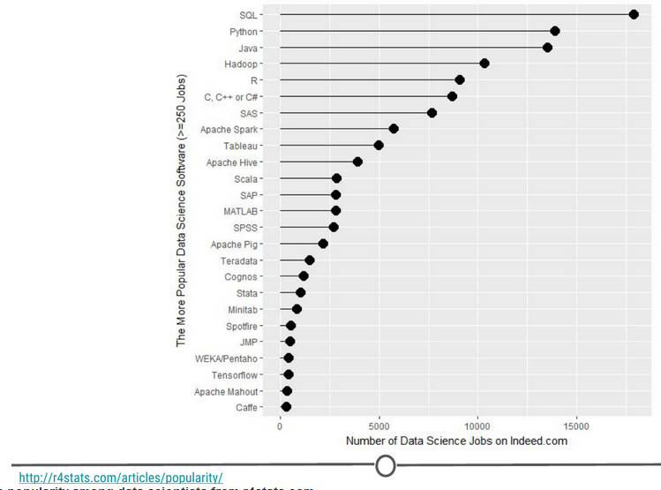

**R’s popularity among data scientists from r4stats.com**

**2) Its cost**

FREE!

This one is pretty self-explanatory - every aspect of R is free to use, unlike some other stats packages you may have heard of (eg: SAS, SPSS), so there is no cost barrier to using R!

**3) Its extensive functionality**

R is a very versatile language - we’ve talked about its use in stats and in graphing, but its use can be expanded to many different functions - from making [websites](http://rmarkdown.rstudio.com/rmarkdown_websites.html), making maps using [GIS data](http://www.nickeubank.com/gis-in-r/), analysing [language](https://cran.r-project.org/web/views/NaturalLanguageProcessing.html)… and even making these [lectures and videos](https://cran.r-project.org/web/packages/ari/index.html)! For whatever task you have in mind, there is often a package available for download that does exactly that!

**4) Its community**

And the reason that the functionality of R is so extensive is the community that has been built around R. Individuals have come together to make “packages” that add to the functionality of R - and more are being developed every day!

Particularly for people just getting started out with R, its community is a huge benefit - due to its popularity, there are multiple forums that have pages and pages dedicated to solving R problems. We talked about this in the Getting Help lesson; these forums are great both for finding other people who have had the same problem as you, and posting your own new problems.

### Installing R

Now that we’ve spent some time looking at the benefits of R, it is time to install it! We’ll go over installation for both Windows and Mac below, but know that these are general guidelines and small details are likely to change subsequent to the making of this lecture - use this as a scaffold.

For both Windows and Mac machines, we start at the CRAN homepage: <https://cran.r-project.org/>

### Installation - for Windows

If you are on a Windows computer, follow the link [Download R for Windows](https://cran.r-project.org/bin/windows/), and follow the directions there - if this is your first time installing R, go to the [base distribution](https://cran.r-project.org/bin/windows/base/) and click on the link at the top of the page that should say something like “Download R [version number] for Windows.” This will download an executable file for installation.

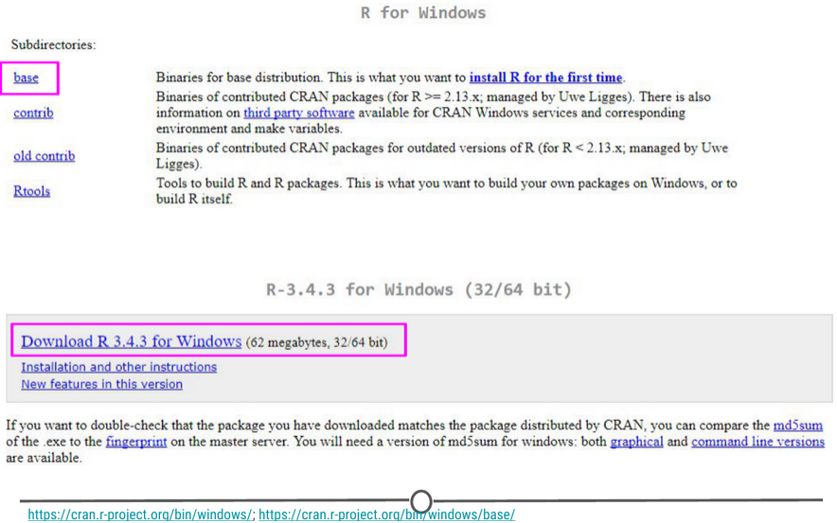

The download page for R on Windows

Open the executable, and if prompted by a security warning, allow it to run. Select the language you prefer during installation and agree to the licensing information. You will next be prompted for a destination location - this will likely be defaulted to Program Files, in a subfolder called R, followed by another directory of the version number. Unless you have any issues with this, the default location is perfect.

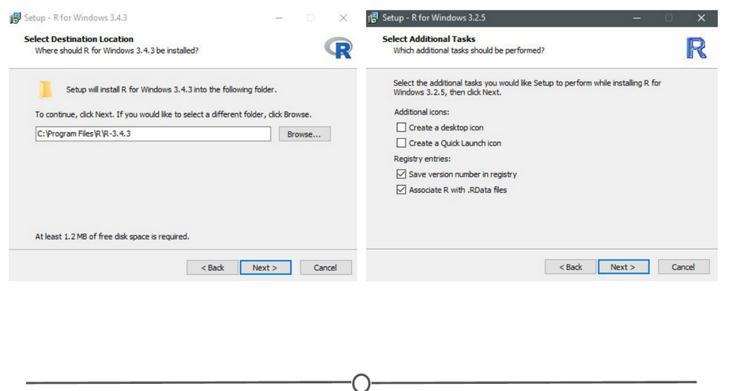

**The install wizard for installing R**

You will then be prompted to select which components should be installed. Unless you are running short on memory, installing all of the components is desireable. Next you’ll be asked about startup options, and again, the defaults are fine for this. You will then be asked where Setup should place shortcuts - this is completely up to you, you can allow it to add the program to the start menu, or you can click the box at the bottom that says to not create a start menu link. Finally, you will be asked whether you want a desktop or Quick Launch icon - up to you! I do not recommend changing the defaults for the registry entries though.

After this window, the installation should begin. Test that the installation worked by opening R for the first time!

## Installation - for Macs

If you are on a Mac computer, follow the link [Download R for (Mac) OS X](https://cran.r-project.org/bin/macosx/). There you can find the various R versions for download. Note: If your Mac is older than OS X 10.6 (“Snow Leopard”), you will need to follow the directions on this page for downloading older versions of R that are compatible with those operating systems.

Click on the link to the most recent version of R, which will download a .pkg file.

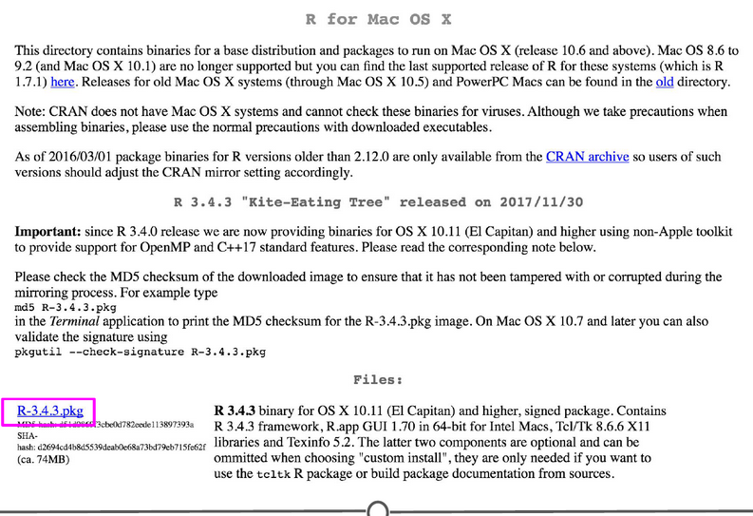

**Downloading the .pkg file for Macs**

Open the pkg file and follow the prompts as provided by the installer. First, click continue on the welcome page and again on the important information window page. Next you will be presented with the software license agreement, again, continue. Next you may be asked to select a destination for R, either available to all users or to a specific disk - select whichever you feel is best suited to your setup. Finally, you will be at the “Standard Install” page; R selects a default directory and if you are happy with that location, go ahead and click install. At this point, you may be prompted to type in the admin password, do so, and the install will begin!

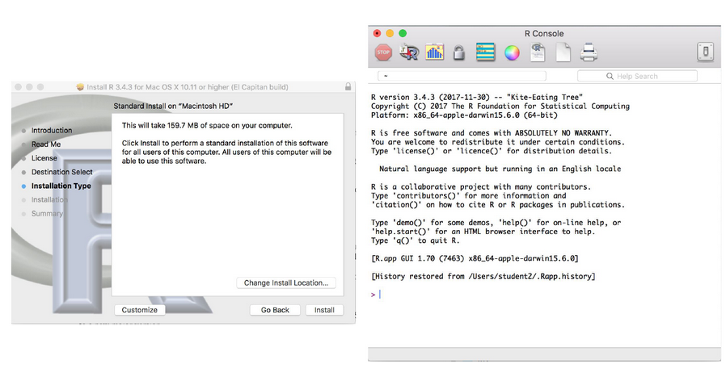

**Installation of R on a Mac**

Once the installation is finished, go to your Applications and find R. Test that the installation worked by opening R for the first time!

### Summary

In this lesson we first looked at what R is and why we might want to use it. We then focused on the installation process for R on both Windows and Mac computers. Before moving on to the next lecture, be sure that you have R installed properly.

## W2 2 - Installing R Studio

We’ve installed R and can open the R interface to input code, but there are other ways to interface with R - and one of those ways is using RStudio. In this lesson, we’ll get RStudio installed on your computer.

### What is RStudio?

[RStudio](https://www.rstudio.com/products/RStudio/) is a graphical user interface for R, that allows you to write, edit and store code, generate, view and store plots, manage files, objects and dataframes, and integrate with version control systems – to name a few of its functions. We will be exploring exactly what RStudio can do for you in future lessons, but for anybody just starting out with R coding, the visual nature of this program as an interface for R is a huge benefit.

### Installing RStudio

Thankfully, installation of RStudio is fairly straightforward. First, you go to the [RStudio download page](https://www.rstudio.com/products/rstudio/download/https:/www.rstudio.com/products/rstudio/download/). We want to download the RStudio Desktop version of the software, so click on the appropriate “Download” , under that heading and you will see a list of [“Installers for supported platforms”](https://www.rstudio.com/products/rstudio/download/#download).

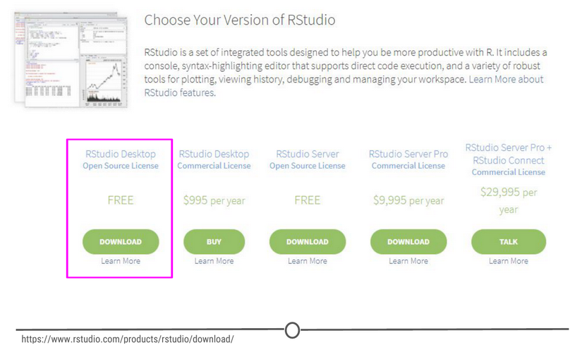

**The RStudio download page. Select RStudio Desktop**

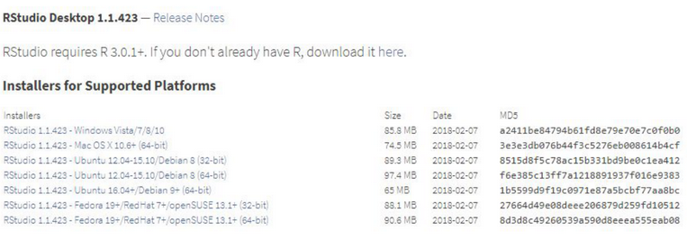

**The various versions of RStudio available for different operating systems**

At this point the installation process diverges for Macs and Windows, so follow the instructions for the appropriate OS.

### Installing RStudio - Windows

For Windows, select the RStudio installer for the various Windows editions (Vista, 7, 8, 10). This will initiate the download process. When the download is complete, open this executable file to access the installation wizard. You may be presented with a security warning at this time - allow it to make changes to your computer.

Following this, the installation wizard will open. Following the defaults on each of the windows of the wizard is appropriate for installation. In brief, on the welcome screen, click next. If you want RStudio installed elsewhere, “Browse” through your file system. Otherwise, it will likely default to the “Program Files” folder - this is appropriate. Click next. On this final page, allow RStudio to create a Start menu shortcut. Click Install. RStudio is now being installed. Wait for this process to finish; RStudio is now installed on your computer. Click Finish.

Check that RStudio is working appropriately by opening it from your Start menu.

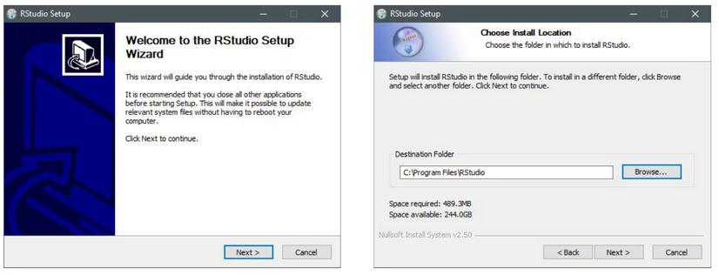

**The installation wizard for RStudio installation**

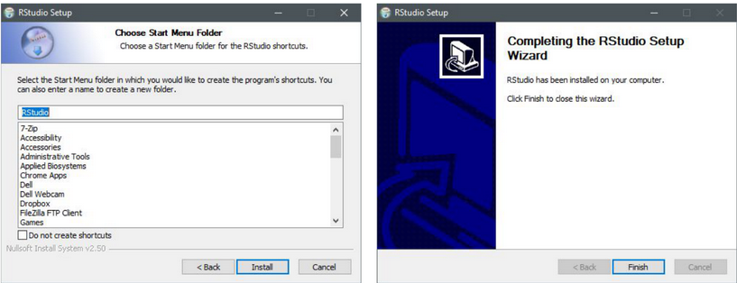

**Completing installation of RStudio**

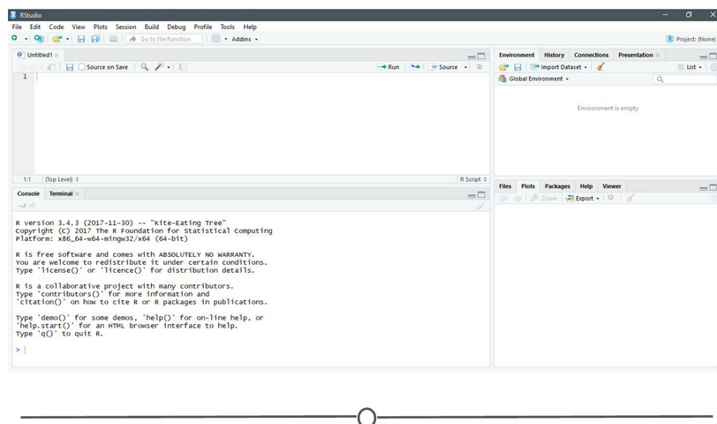

**RStudio is running!**

## Installing RStudio - Macs

For Macs, select the Macs OS X RStudio installer (Mac OS X 10.6+ (64-bit)). This will initiate the download process. When the download is complete, click on the downloaded file and it will begin to install. When this is finished, the applications window will open. Drag the RStudio icon into the Applications directory. Test the installation by opening your applications folder and opening the RStudio software.

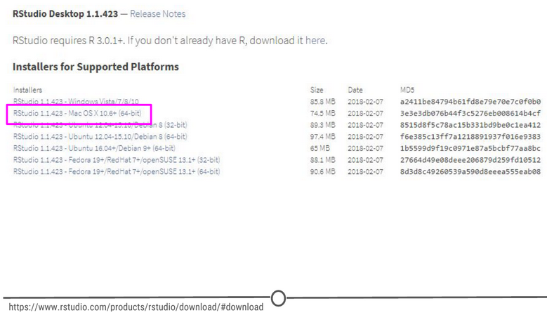

**Download the Mac appropiate version of RStudio**

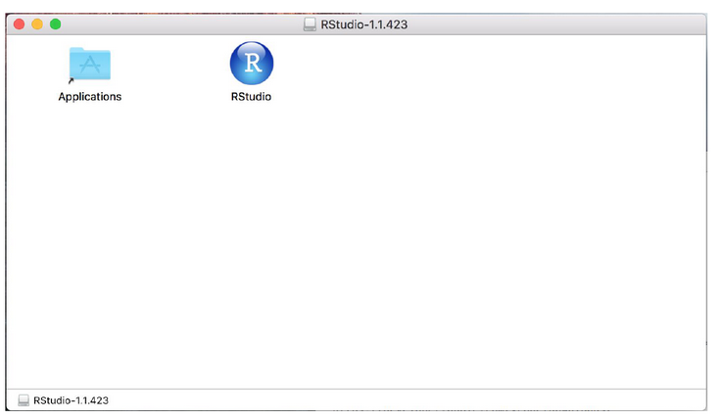

**Drag the RStudio file into your Applications folder to complete installation for RStudio**

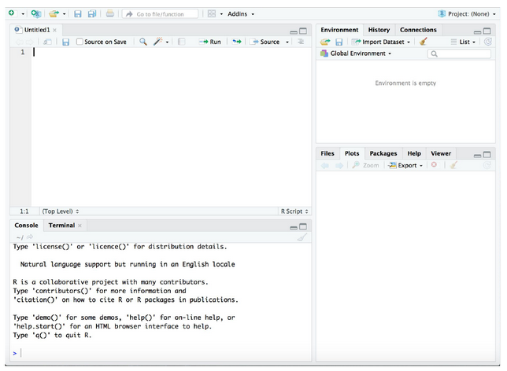

**RStudio is running!**

### Summary

In this lesson we installed RStudio, both for Macs and for Windows computers. Before moving on to the next lecture, click through the available menus and explore the software a bit. We will have an entire lesson dedicated to exploring RStudio, but having some familiarity beforehand will be helpful!

## W2 3 - RStudio Tour

Now that we have RStudio installed, we should familiarize ourselves with the various components and functionality of it! RStudio provides a cheatsheet of the [RStudio environment](https://github.com/rstudio/cheatsheets/raw/master/rstudio-ide.pdf) - warning: this link initiates a download of a PDF from the RStudio GitHub.

### The various quadrants

Rstudio can be roughly divided into four quadrants, each with specific and varied functions, plus a main menu bar. When you first open RStudio, you should see a window that looks roughly like this

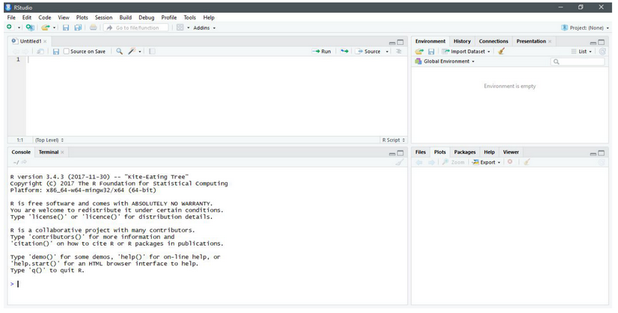

**RStudio’s main interface**

You may be missing the upper left quadrant and instead have the left side of the screen with just one region, “Console” - if this is the case, go to File > New File > R Script and now it should more closely resemble the image. You can change the sizes of each of the various quadrants by hovering your mouse over the spaces between quadrants and click-dragging the divider to resize the sections.

We will go through each of the regions and describe some of their main functions. It would be impossible to cover everything that RStudio can do, so we urge you to explore RStudio on your own too!

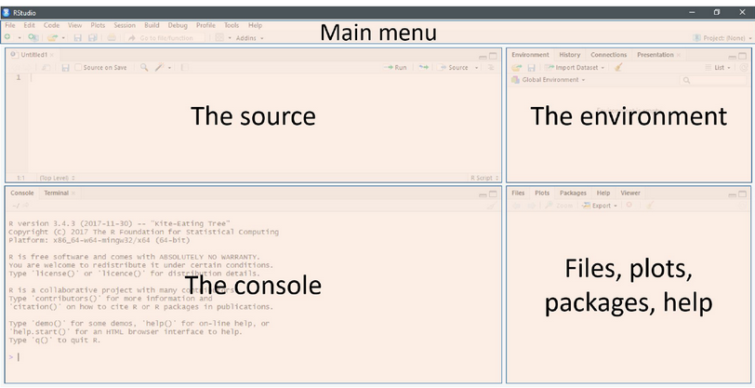

**The four main quadrants of RStudio, plus the main menu bar**

### The menu bar

The menu bar runs across the top of your screen and should have two rows. The first row should be a fairly standard menu, starting with “File” and “Edit.” Below that, there is a row of icons that are shortcuts for functions that you’ll frequently use.

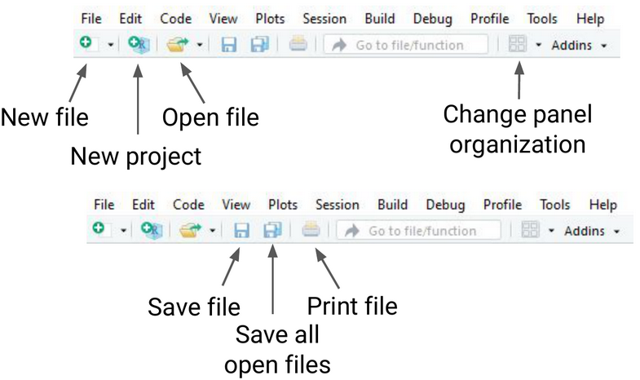

**The commonly used options of the main menu bar**

To start, let’s explore the main sections of the menu bar that you will use. The first being the File menu. Here we can open new or saved files, open new or saved projects (we’ll have an entire lesson in the future about R Projects, so stay tuned!), save our current document or close RStudio. If you mouse over “New File”, a new menu will appear that suggests the various file formats available to you. R Script and R Markdown files are the most common file types for use, but you can also generate R notebooks, web apps, websites, or slide presentations. If you click on any one of these, a new tab in the “Source” quadrant will open. We’ll spend more time in a future lesson on R Markdown files and their use.

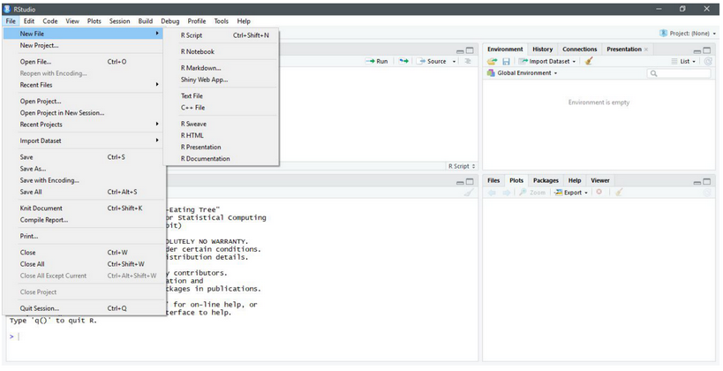

**he File menu**

The Session menu has some R specific functions, in which you can restart, interrupt or terminate R - these can be helpful if R isn’t behaving or is stuck and you want to stop what it is doing and start from scratch.

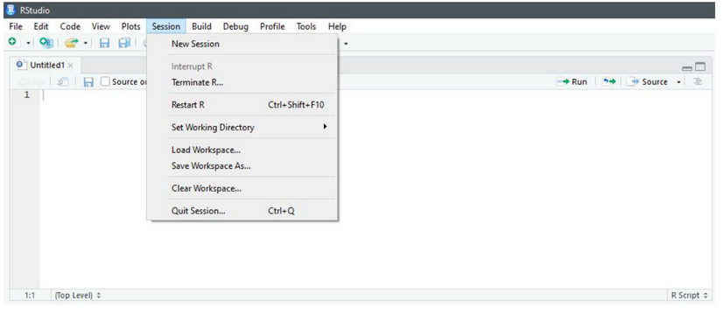

**The Session menu**

The Tools menu is a treasure trove of functions for you to explore. For now, you should know that this is where you can go to install new packages (see next lecture), set up your version control software (see future lesson: Linking GitHub and RStudio), and set your options and preferences for how RStudio looks and functions. For now, we will leave this alone, but be sure to explore these menus on your own once you have a bit more experience with RStudio and see what you can change to best suit your preferences!

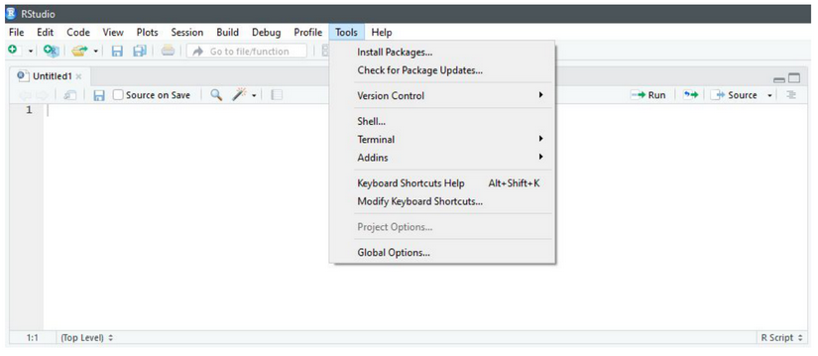

**he Tools menu**

### The console

This region should look familiar to you - when you opened R, you were presented with the console. This is where you type and execute commands, and where the output of said command is displayed.

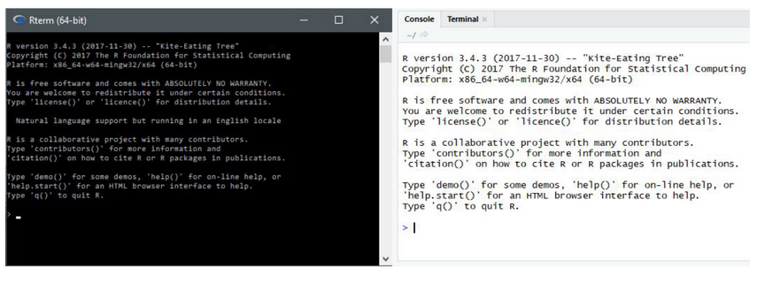

**The console**

To execute your first command, try typing 1 + 1 then enter at the > prompt. You should see the output [1] 2 below your command.

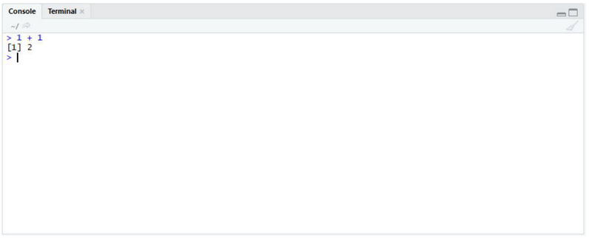

**Typing into the console and getting an output**

Now copy and paste the following into your console and hit enter.

example <- matrix(c(1, 2, 3, 4, 5, 6, 7, 8), nrow = 4, ncol = 2)

This creates a matrix with four rows and two columns, with the numbers 1 through 8.

### The environment/history

To view this matrix, first look to the Environment quadrant, where you should see the following:

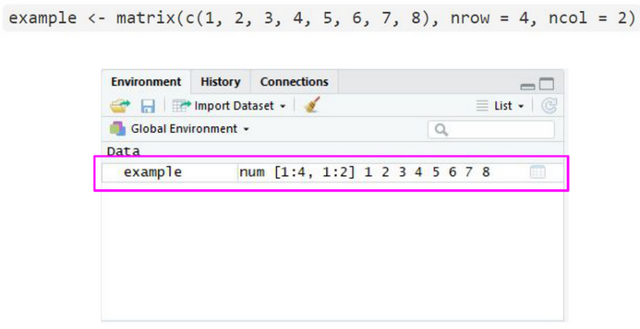

**The environment quadrant**

Click anywhere on the “example” line, and a new tab on the Source quadrant should appear, showing the matrix you created. Any dataframe or matrix that you create in R can be viewed this way in RStudio.

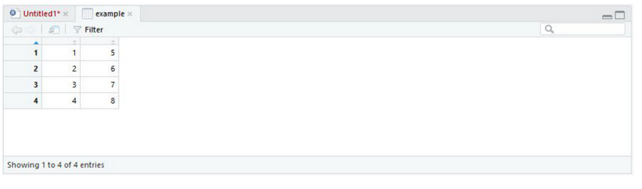

**Your newly made matrix, opened in a new tab of the source panel**

RStudio also tells you some information about the object in the environment, like whether it is a list or a dataframe or if it contains numbers, integers or characters. This is very helpful information to have as some functions only work with certain classes of data. And knowing what kind of data you have is the first step to that.

The quadrant has two other tabs running across the top of it. We’ll just look at the History tab now. Your history tab should look something like this:

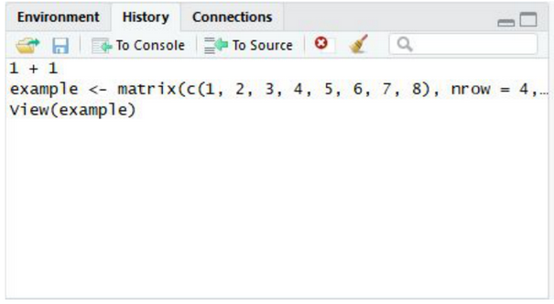

**The history tab**

Here you will see the commands that we have run in this session of R. If you click on any one of them, you can click “To Console” or “To Source” and this will either rerun the command in the console, or will move the command to the source, respectively. Do so now for your example matrix and send it to Source.

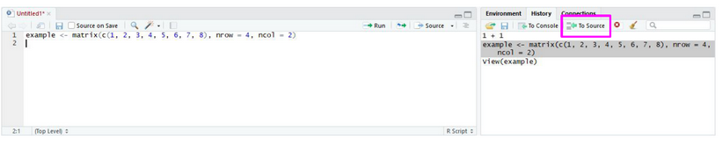

**The history tab**

### The source/The script editor panel

The Source panel is where you will be spending most of your time in RStudio. This is where you store the R commands that you want to save for later, either as a record of what you did or as a way to rerun code. We’ll spend a lot of time in this quadrant when we discuss R Markdown, but for now, click the save icon along the top of this quadrant and save the script as my_first_R_script.R Now you will always have a record of creating this matrix.

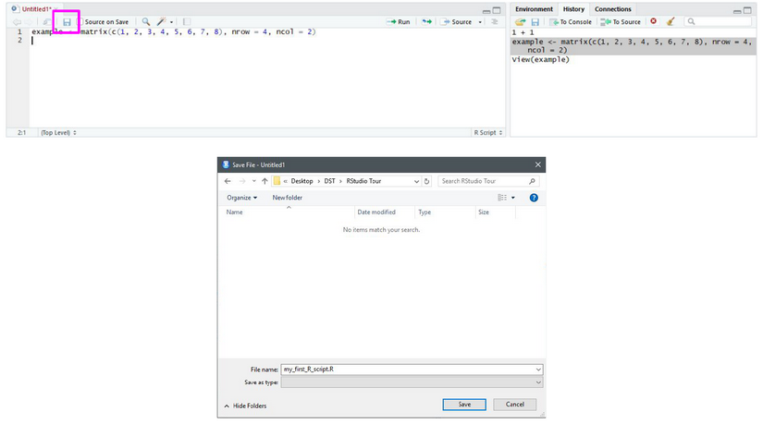

**Your first R script!**

### Files/help/plots/packages panel

The final region we’ll look at occupies the bottom right of the RStudio window. In this quadrant, five tabs run across the top: Files, Plots, Packages, Help, and Viewer.

In Files, you can see all of the files in your current working directory. If this isn’t where you want to save or retrieve files from, you can also change the current working directory in this tab using the ellipsis at the far right, finding the desired folder, and then under the “More” cogwheel, setting this new folder as the working directory.

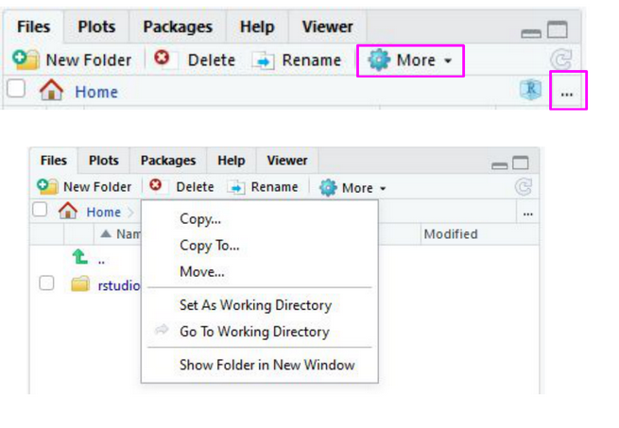

**The files tab**

In the Plots tab, if you generate a plot with your code, it will appear here. You can use the arrows to navigate to previously generated plots. The Zoom function will open the plot in a new window, that is much larger than the quadrant. Export is how you save the plot. You can either save it as an image or as a PDF. The broom icon clears all plots from memory.

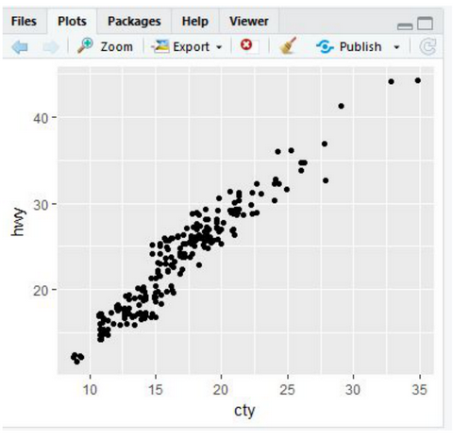

**The plots tab**

The Packages tab will be explored more in depth in the next lesson on R packages. Here you can see all the packages you have installed, load and unload these packages, and update them.

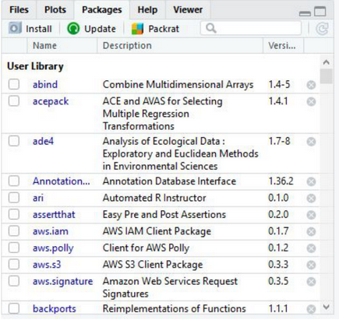

**The packages tab**

The Help tab is where you find the documentation for your R packages and various functions. In the upper right of this panel there is a search function for when you have a specific function or package in question.

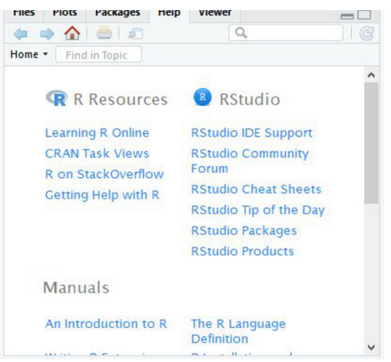

**The help tab**

### Summary

In this lesson we took a tour of the RStudio software. We became familiar with the main menu and its various menus. We looked at the Console, where R code is input and run. We then moved on to the Environment panel that lists all of the objects that have been created within an R session and allows you to view these objects in a new tab in Source. In this same quadrant, there is a History tab, that keeps a record of all commands that have been run. It also presents the option to either rerun the command in the Console, or send the command to Source, to be saved. Source is where you save your R commands. And the bottom right quadrant contains a listing of all the files in your working directory, displays generated plots, lists your installed packages, and supplies help files for when you need some assistance! Take some time to explore RStudio on your own!

## W2 4 - R Packages

Now that we’ve installed R and RStudio and have a basic understanding of how they work together, we can get at what makes R so special: packages.

### What is an R package?

So far, anything we’ve played around with in R uses the “base” R system. Base R, or everything included in R when you download it, has rather basic functionality for statistics and plotting but it can sometimes be limiting. To expand upon R’s basic functionality, people have developed **packages.** A package is a collection of functions, data, and code conveniently provided in a nice, complete format for you. At the time of writing, there are just over 14,300 packages available to download - each with their own specialized functions and code, all for some different purpose. For a really in depth look at R Packages (what they are, how to develop them), check out Hadley Wickham’s book from O’Reilly, [“R Packages.”](http://r-pkgs.had.co.nz/)

Side note: A package is not to be confused with a **library** (these two terms are often conflated in colloquial speech about R). A library is the place where the package is located on your computer. To think of an analogy, a library is, well, a library… and a package is a book within the library. The library is where the books/packages are located.

Packages are what make R so unique. Not only does base R have some great functionality but these packages greatly expand its functionality. And perhaps most special of all, each package is developed and published by the R community at large and deposited in **repositories.**

### What are repositories?

A repository is a central location where many developed packages are located and available for download.

There are three big repositories:  
1. [**CRAN (Comprehensive R Archive Network):**](https://cran.r-project.org/web/packages/) R’s main repository (>12,100 packages available!)  
2. [**BioConductor:**](https://bioconductor.org/packages/release/BiocViews.html#___Software) A repository mainly for bioinformatic-focused packages  
3. [**GitHub:**](https://github.com/collections) A very popular, open source repository (not R specific!)

Take a second to explore the links above and check out the various packages that are out there!



**The big three repositories for R packages**

### How do you know what package is right for you?

So you know where to find packages… but there are so many of them, how can you find a package that will do what you are trying to do in R? There are a few different avenues for exploring packages.

First, CRAN groups all of its packages by their functionality/topic into 35 “themes.” It calls this its [“Task view.”](https://cran.r-project.org/web/views/) This at least allows you to narrow the packages you can look through to a topic relevant to your interests.

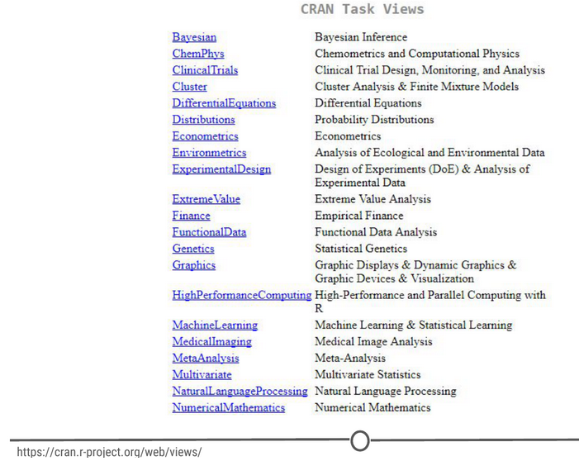

**CRAN’s “Task View” that groups packages into 35 topics**

Second, there is a great website, [**RDocumentation,**](https://www.rdocumentation.org) which is a search engine for packages and functions from CRAN, BioConductor, and GitHub (ie: the big three repositories). If you have a task in mind, this is a great way to search for specific packages to help you accomplish that task! It also has a [“task” view](https://www.rdocumentation.org/taskviews) like CRAN, that allows you to browse themes.

More often, if you have a specific task in mind, Googling that task followed by “R package” is a great place to start! From there, looking at tutorials, vignettes, and forums for people already doing what you want to do is a great way to find relevant packages.

### How do you install packages?

Great! You’ve found a package you want… How do you install it?

**Installing from CRAN**  
If you are installing from the CRAN repository, use the install.packages() function, with the name of the package you want to install in quotes between the parentheses (note: you can use either single or double quotes). For example, if you want to install the package “ggplot2”, you would use: install.packages("ggplot2")

Try doing so in your R console! This command downloads the “ggplot2” package from CRAN and installs it onto your computer.

If you want to install multiple packages at once, you can do so by using a character vector, like: install.packages(c("ggplot2", "devtools", "lme4"))

If you want to use RStudio’s graphical interface to install packages, go to the Tools menu, and the first option should be “Install packages…” If installing from CRAN, select it as the repository and type the desired packages in the appropriate box.

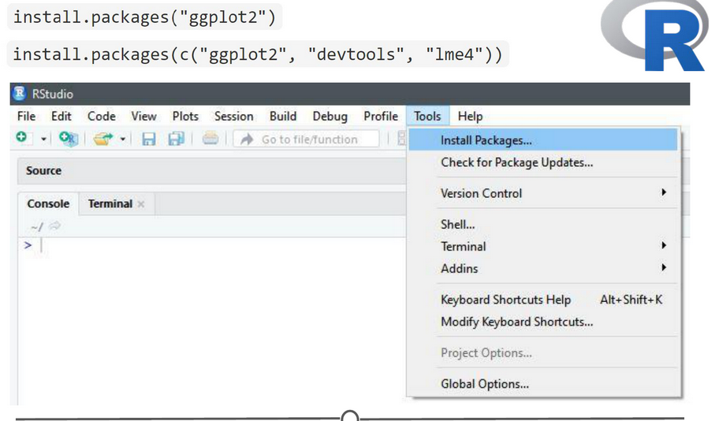

**Various methods to install packages within R/RStudio**

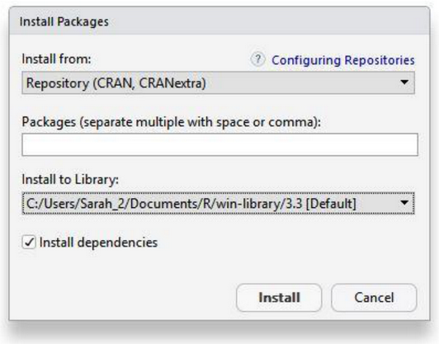

**Installing packages from CRAN through R/RStudio**

**Installing from Bioconductor**  
The BioConductor repository uses their own method to [install packages](https://www.bioconductor.org/install/). First, to get the basic functions required to install through BioConductor, use: source("https://bioconductor.org/biocLite.R")

This makes the main install function of BioConductor, biocLite(), available to you. Following this, you call the package you want to install in quotes, between the parentheses of the biocLite command, like so: biocLite("GenomicFeatures")



**Installing packages with BioConductor**

**Installing from GitHub**  
This is a more specific case that you probably won’t run into too often. In the event you want to do this, you first must find the package you want on GitHub and take note of both the package name AND the author of the package. Check out [this guide](http://kbroman.org/pkg_primer/pages/github.html) for installing from GitHub, but the general workflow is:

1. install.packages("devtools") - only run this if you don’t already have devtools installed. If you’ve been following along with this lesson, you may have installed it when we were practicing installations using the R console
2. library(devtools) - more on what this command is doing immediately below this
3. install_github("author/package") replacing “author” and “package” with their GitHub username and the name of the package.

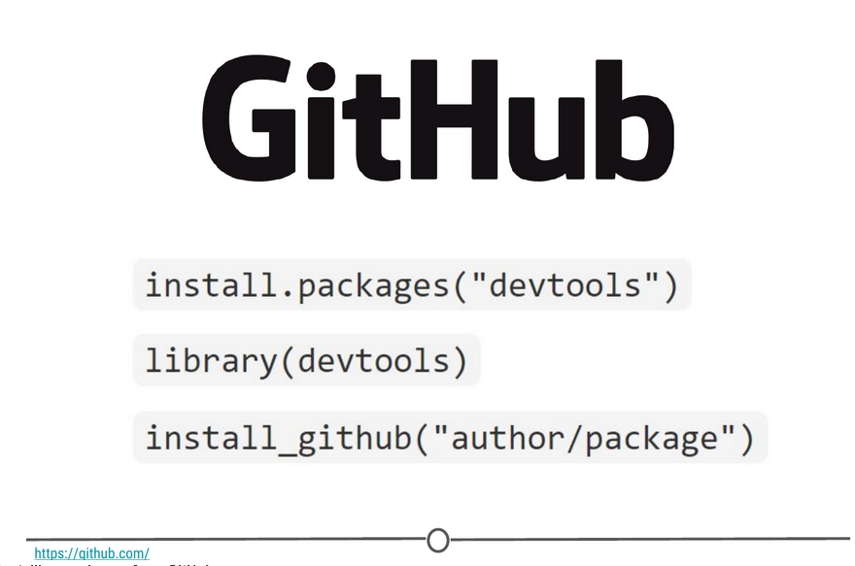

**Installing packages from GitHub**

### Loading packages

Installing a package does not make its functions immediately available to you. First you must **load** the package into R; to do so, use the library() function. Think of this like any other software you install on your computer. Just because you’ve installed a program, doesn’t mean it’s automatically running - you have to open the program. Same with R. You’ve installed it, but now you have to “open” it. For example, to “open” the “ggplot2” package, you would run:library(ggplot2)

**NOTE:** Do **not** put the package name in quotes! Unlike when you are installing the packages, the library() command does not accept package names in quotes!

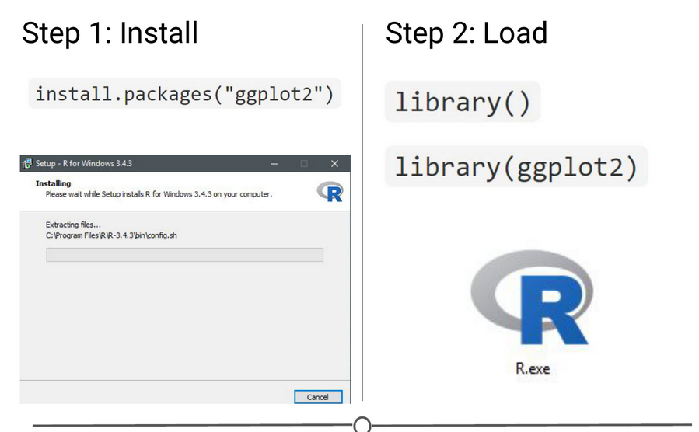

**Step one of getting a package is installing it, but to use it, you must load it using library(); similar to installing R and then loading it by opening the .exe file**

There is an order to loading packages - some packages require other packages to be loaded first (**dependencies**). That package’s manual/help pages will help you out in finding that order, if they are picky.

If you want to load a package using the RStudio interface, in the lower right quadrant there is a tab called “Packages” that lists out all of the packages and a brief description, as well as the version number, of all of the packages you have installed. To load a package just click on the checkbox beside the package name

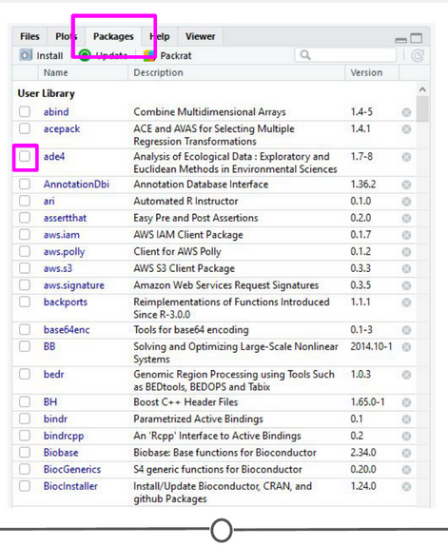

**Using the RStudio interface to load a package**

### Updating, removing, unloading packages

Once you’ve got a package, there are a few things you might need to know how to do:

**Checking what packages you have installed**  
If you aren’t sure if you’ve already installed a package, or want to check what packages are installed, you can use either of: installed.packages() or library() with nothing between the parentheses to check!

In RStudio, that package tab introduced earlier is another way to look at all of the packages you have installed.

**Updating packages**

You can check what packages need an update with a call to the function old.packages() This will identify all packages that have been updated since you installed them/last updated them.

To update all packages, use update.packages(). If you only want to update a specific package, just use once again install.packages("packagename")

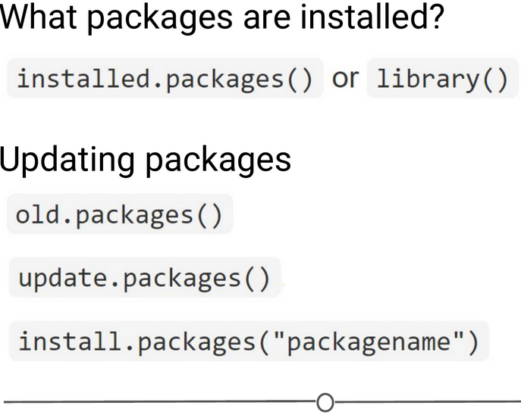

**Functions used to see what packages are installed and update them**

Within the RStudio interface, still in that Packages tab, you can click “Update,” which will list all of the packages that are not up to date. It gives you the option to update all of your packages, or allows you to select specific packages.

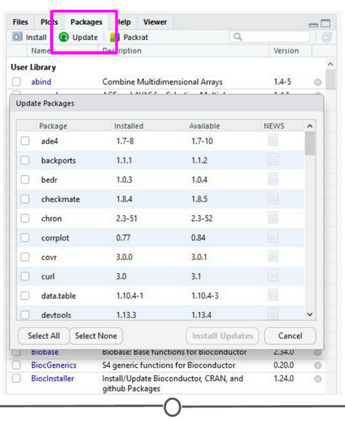

**Using the RStudio interface to update your packages**

You will want to periodically check in on your packages and check if you’ve fallen out of date - be careful though! Sometimes an update can change the functionality of certain functions, so if you re-run some old code, the command may be changed or perhaps even outright gone and you will need to update your code too!

**Unloading packages**

Sometimes you want to unload a package in the middle of a script - the package you have loaded may not play nicely with another package you want to use.

To unload a given package you can use the detach() function. For example, detach("package:ggplot2", unload=TRUE) would unload the ggplot2 package (that we loaded earlier). Within the RStudio interface, in the Packages tab, you can simply unload a package by unchecking the box beside the package name.

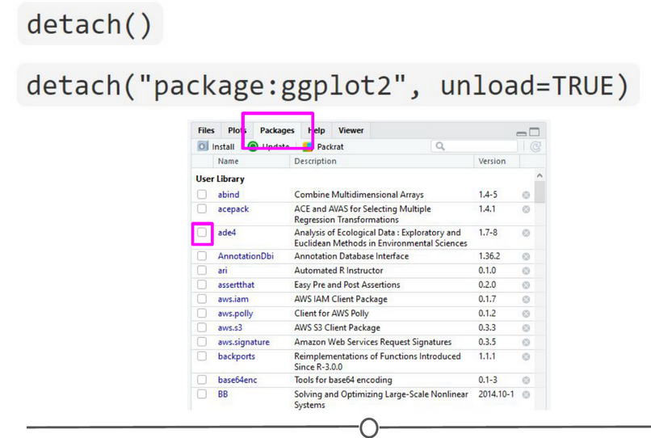

**Unloading or “detaching” a package**

**Uninstalling packages**

If you no longer want to have a package installed, you can simply uninstall it using the function remove.packages(). For example, remove.packages("ggplot2")

(Try that, but then actually re-install the ggplot2 package - it’s a super useful plotting package!)

Within RStudio, in the Packages tab, clicking on the “X” at the end of a package’s row will uninstall that package.

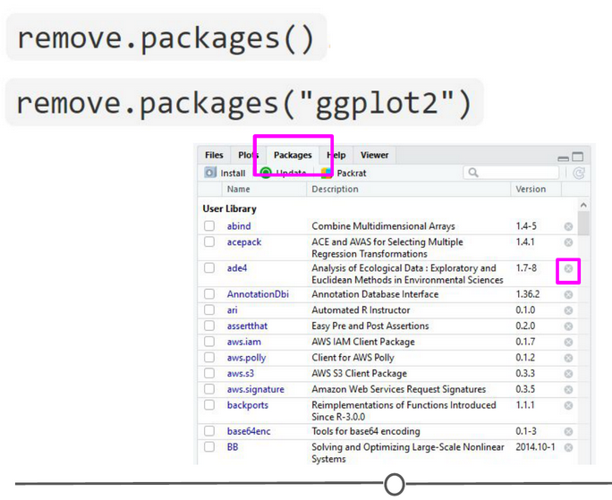

**Uninstalling packages**

**Sidenote: How do you know what version of R you have?**

Sometimes, when you are looking at a package that you might want to install, you will see that it requires a certain version of R to run. To know if you can use that package, you need to know what version of R you are running!

One way to know your R version is to check when you first open R/RStudio - the first thing it outputs in the console tells you what version of R is currently running. If you didn’t pay attention at the beginning, you can type version into the console and it will output information on the R version you are running. Another helpful command is sessionInfo() - it will tell you what version of R you are running along with a listing of all of the packages you have loaded. The output of this command is a great detail to include when posting a question to forums - it tells potential helpers a lot of information about your OS, R, and the packages (plus their version numbers!) that you are using.

KernS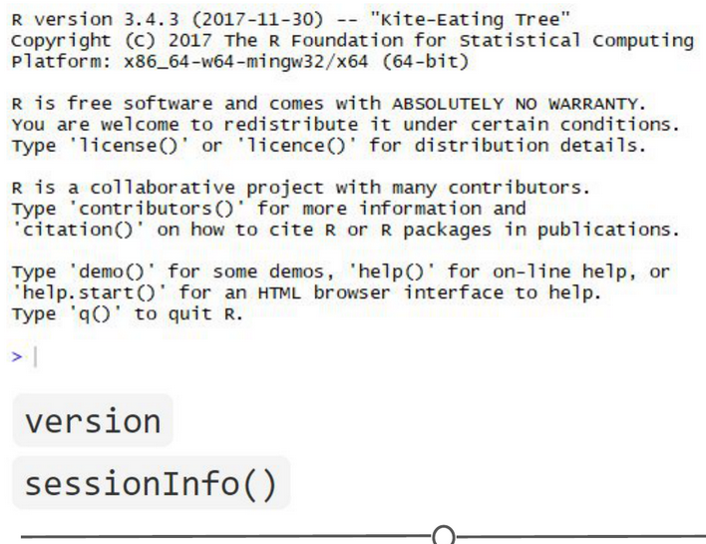

**Ways to see what version of R you are running**

### Using the commands in a function

In all of this information about packages, we haven’t actually discussed how to use a package’s functions!

First, you need to know what functions are included within a package. To do this, you can look at the man/help pages included in all (well-made) packages. In the console, you can use the help() function to access a package’s help files. Try help(package = "ggplot2") and you will see all of the many functions that ggplot2 provides. Within the RStudio interface, you can access the help files through the Packages tab (again) - clicking on any package name should open up the associated help files in the “Help” tab, found in that same quadrant, beside the Packages tab. Clicking on any one of these help pages will take you to that functions help page, that tells you what that function is for and how to use it.

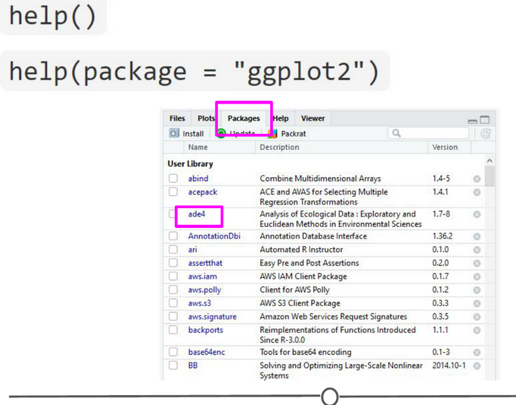

**The help functions available to you**

Once you know what function within a package you want to use, you simply call it in the console like any other function we’ve been using throughout this lesson. Once a package has been loaded, it is as if it were a part of the base R functionality.

If you still have questions about what functions within a package are right for you or how to use them, many packages include **“vignettes.”** These are extended help files, that include an overview of the package and its functions, but often they go the extra mile and include detailed examples of how to use the functions in plain words that you can follow along with to see how to use the package. To see the vignettes included in a package, you can use the browseVignettes() function. For example, let’s look at the vignettes included in ggplot2:browseVignettes("ggplot2") . You should see that there are two included vignettes: “Extending ggplot2” and “Aesthetic specifications.” Exploring the Aesthetic specifications vignette is a great example of how vignettes can be helpful, clear instructions on how to use the included functions.

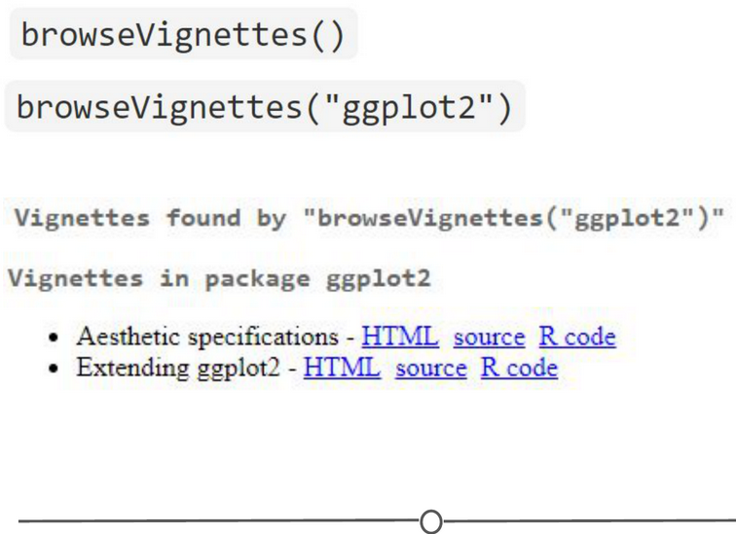

**How to browse vignettes for packages**

### Summary

In this lesson, we’ve explored R packages in depth. We examined what a packages is (and how it differs from a library), what repositories are, and how to find a package relevant to your interests. We investigated all aspects of how packages work: how to install them (from the various repositories), how to load them, how to check which packages are installed, and how to update, uninstall, and unload packages. We took a small detour and looked at how to check what version of R you have, which is often an important detail to know when installing packages. And finally, we spent some time learning how to explore help files and vignettes, which often give you a good idea of how to use a package and all of its functions.

If you still want to learn more about R packages, here are two great resources! [R Packages: A Beginner’s Guide](https://www.datacamp.com/community/tutorials/r-packages-guide) from Adolfo Álvarez on DataCamp and a lesson from the University of Washington, on an [Introduction to R Packages](http://faculty.washington.edu/kenrice/rintro/sess08.pdf) from Ken Rice and Timothy Thornton.

## W2 5 - Projects in R

One of the ways people organize their work in R is through the use of R Projects, a built in functionality of RStudio that helps to keep all your related files together. RStudio provides a [great guide](https://support.rstudio.com/hc/en-us/articles/200526207-Using-Projects) on how to use Projects so definitely check that out!

### What is an R Project?

When you make a Project, it creates a folder where all files will be kept, which is helpful for organizing yourself and keeping multiple projects separate from each other. When you re-open a project, RStudio remembers what files were open and will restore the work environment as if you had never left - which is very helpful when you are starting back up on a project after some time off! Functionally, creating a Project in R will create a new folder and assign that as the working directory so that all files generated will be assigned to the same directory.

### What are the benefits to using Projects?

The main benefit of using Projects is that it starts the organization process off right! It creates a folder for you and now you have a place to store all of your input data, your code, and the output of your code. Everything you are working on within a Project is self-contained; which often means finding things is much easier - there’s only one place to look!

Also, since everything related to one project is all in the same place, it is much easier to share your work with others - either by directly sharing the folder/files, or by associating it with version control software. We’ll talk more about linking Projects in R with version control systems in a future lesson entirely dedicated to the topic!

Finally, since RStudio remembers what documents you had open when you closed the session, it is easier to pick a project up after a break - everything is set-up just as you left it!

### Creating a Project

There are three ways to make a Project:  
1) From scratch - this will create a new directory for all your files to go in  
2) From an existing folder - this will link an existing directory with RStudio  
3) From version control - this will “clone” an existing project onto your computer (Don’t worry too much about this one, you’ll get more familiar with it in the next few lessons)

Let’s create a Project from scratch, which is often what you will be doing!

Open RStudio, and under File, select “New Project”. You can also create a new Project by using the Projects toolbar and selecting “New Project” in the drop down menu, or there is a “New Project” shortcut in the toolbar.

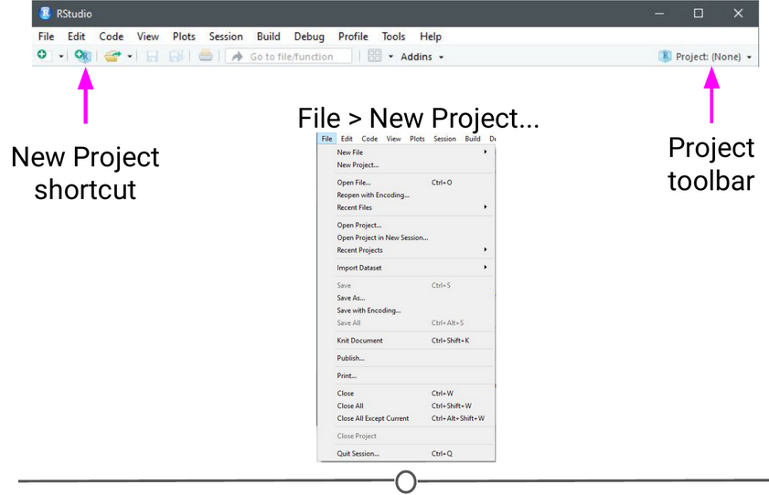

**Ways to initiate a new project**

Since we are starting from scratch, select “New Project” and a window will appear. Select “New Directory” and when prompted about the Project type, select “New Project”

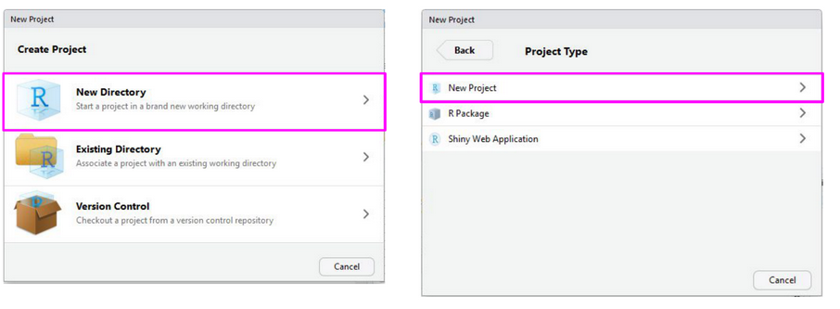

**New project options**

Pick a name for your project and for this time, save it to your Desktop. This will create a folder on your Desktop where all of the files associated with this Project will be kept. Click “Create Project.”

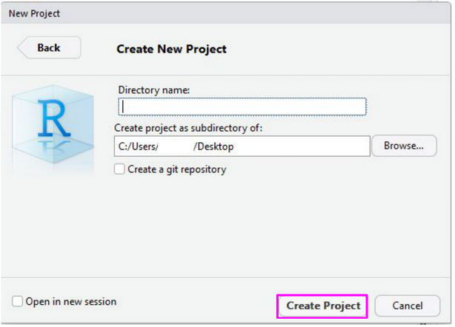

**Creating a new project**

A blank RStudio session should open.

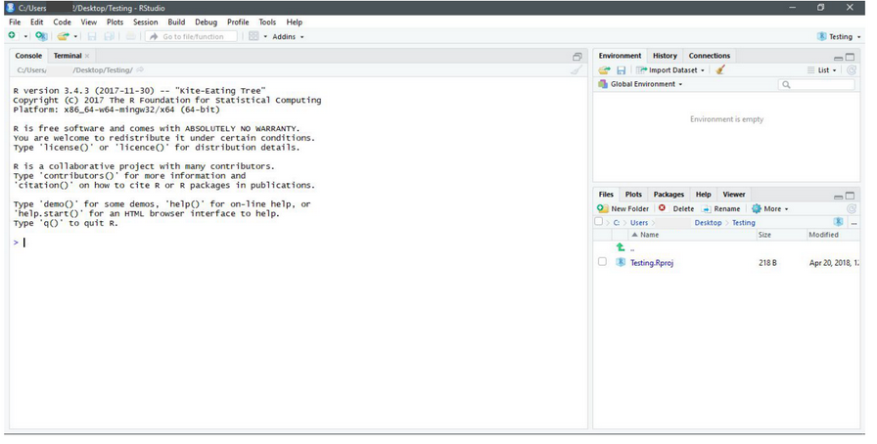

**Your new project**

A few things to note:  
1) In the “Files” quadrant of the screen, you can see that RStudio has made this new directory your working directory and generated a single file with the extension “.Rproj”  
2) In the upper-right of the window, there is a Projects toolbar that states the name of your current Project and has a drop down menu with a few different options that we’ll talk about in a second.

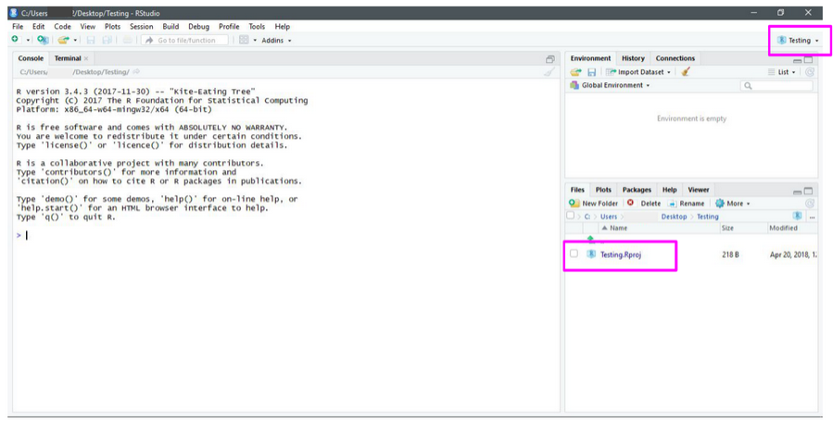

**Note the new project file in the Files quadrant and the Project toolbar**

### Opening a project

Opening an existing Project is as simple as double clicking the .Rproj file on your computer. You can accomplish the same from within RStudio by opening RStudio and going to File > Open Project. You can also use the Project toolbar and open the drop down menu and select “Open Project…”

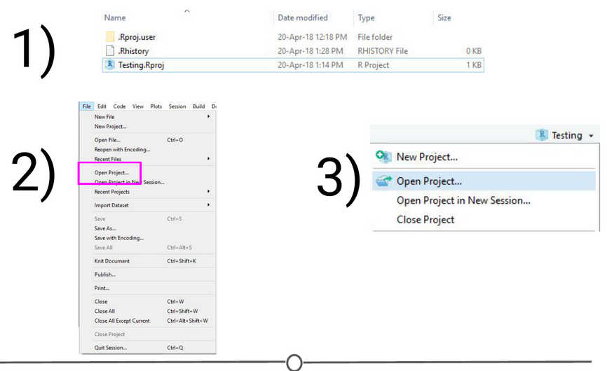

**Ways to open a project**

### Quitting a project or switching to another

Quitting a project is as simple as closing your RStudio window. You can also go to File > Close Project, and this will do the same. Finally, you can use the Project toolbar by clicking on the drop down menu and choosing “Close Project”.

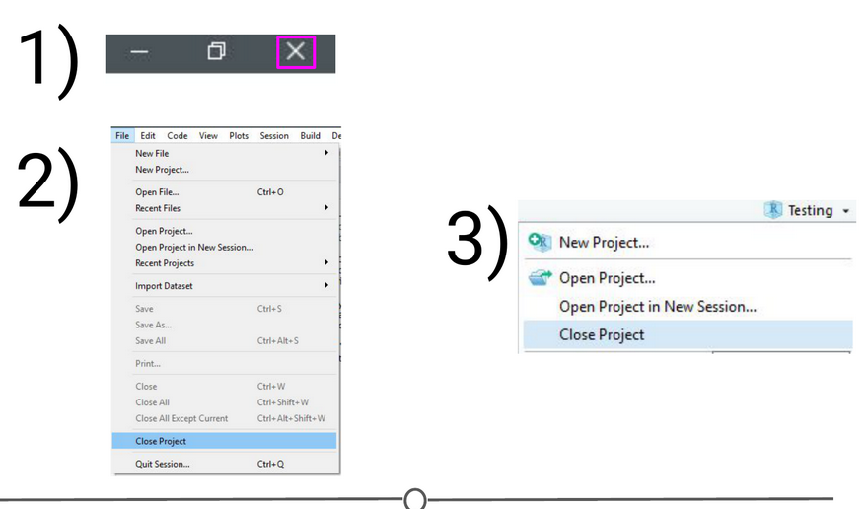

**Ways to quit a project**

All of these options will quit a Project and doing so will cause RStudio to write which documents are currently open (so they can be restored when you start back up again) and it then closes the R session. When you set up your Project, you can tell it to save environment (so, for example, all of your variables and data tables will be preloaded when you reopen the project), but this is not the default behaviour.

The Projects toolbar is also an easy way to switch between Projects - click on the drop down menu and choose “Open Project” and find your new Project you want to open - this will save the current Project, close it, and then open the new Project within the same window. If you want multiple Projects open at the same time, do the same but instead select “Open Project in New Session”. This can also be accomplished through the File menu, where those same options are available.

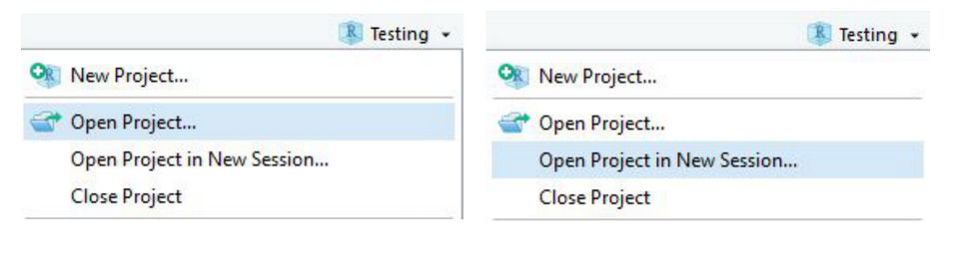

**Ways to switch between projects**

### Best practices

When you are setting up a project, it can be helpful to start out creating a few directories. Try a few strategies and see what works best for you, but most file structures are set-up around having a directory containing the raw data, a directory that you keep scripts/R files in, and a directory for the output of your code.

For example:

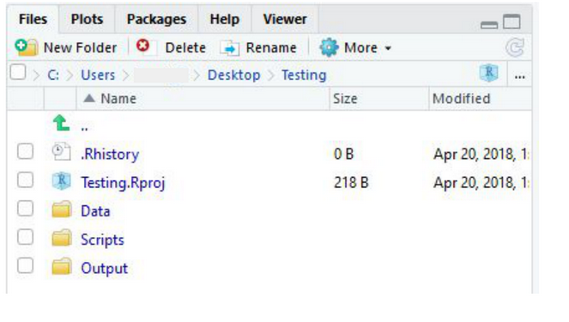

**An example of a possible folder structure to organize your project**

If you set up these folders before you start, it can save you organizational headaches later on in a project when you can’t quite remember where something is!

### Summary

In this lesson we’ve covered what Projects in R are, why you might want to use them, how to open, close, or switch between projects, and some best practices to best set you up for organizing yourself!